CrowSoft Branching Strategy

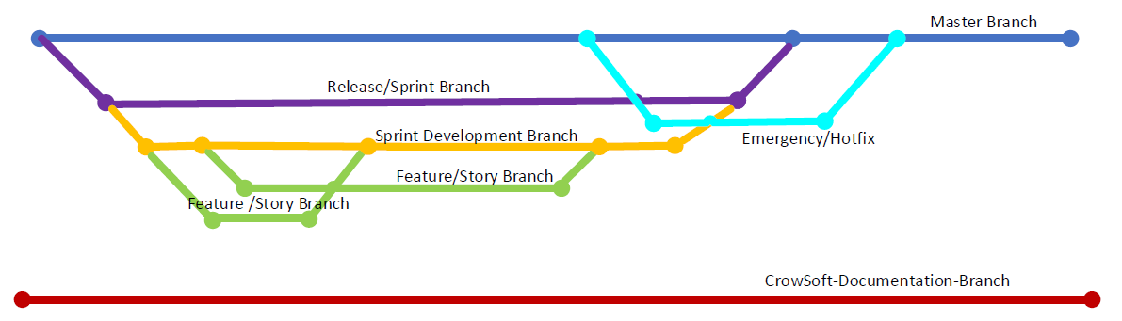

* Master Branch complete code running on Production (no changes pushed to master)
* Release /Sprint branch will be taken from the Master prefixed by release and sprint identifier
* Each Sprint/Release will have a Development branch branched from the Release.
* Each Feature/Story for a Release will be branched from the Development Branch.
* When a feature is complete, tested and peer reviewed a pull request is made to the Development Branch.
* When all development and testing is complete a pull request will be made to the Release Branch from Development.
* When Release is fully verified as complete a pull request will be made to the Master Branch From the Release Branch.
* Emergency/hotfix branch to be taken from Master with pull request made to Master for hotfix
* **CrowSoft-Documentation-Branch** is for documentation only not to be merged with the Master Branch